ST OSWALD’S EARLY BIRD’S CLUB
£3.50/child/session
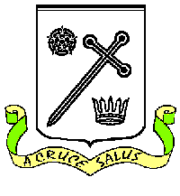
REGISTRATION FORM

Name of child: ……………………………………………………………

Contact number(s) between 7.40 and 8.45 am:
………………………………………………………………………………….

Medical notes – any medical conditions that need to be noted:

Allergies – any known food allergies:

A light breakfast will be provided each day.

Important Information:
Use of the club on an ad-hoc basis will require payment to be made on the same day using ParentPay, our on-line payment service www.parentpay.com For regular attendees, payment should be made in advance and on a regular basis using ParentPay.

Pupils must be signed in each morning by a parent/carer.
Please sign and date below to accept these conditions.

Please see a member of staff should you require any further information or for further details.

Signature of parent/carer: …………………......... Date: …………………..

