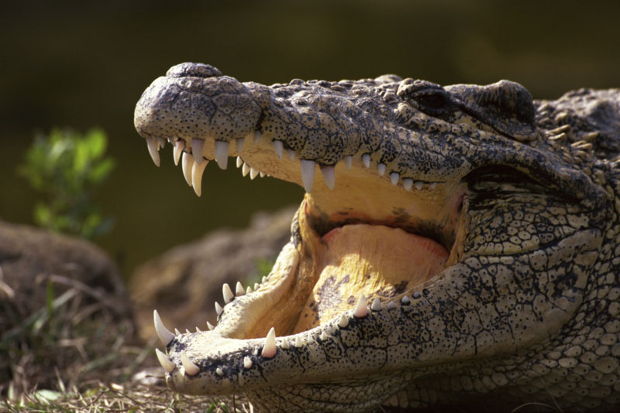
Crocodiles and Alligators

Crocodiles and alligators belong to a group of reptiles called crocodilians. These fierce carnivores (meat-eating animals) have not changed much for millions of years. Today, there are 14 different types of crocodile, 2 types of alligator and 6 types of caiman.

Did you know…
- When baby crocodiles hatch out of their eggs, they call out for their mother.
- Crocodiles and alligators have thick, scaly skin which protects them from being attacked.
- You can tell crocodiles and alligators apart by their teeth. When an alligator shuts its mouth you can’t see any teeth in its bottom jaw. When a crocodile closes its mouth you can see the fourth tooth on each side of its bottom jaw.

Crocodile grazing in the sun.
How fast are alligators?
Alligators, such as the American alligator, can run fast on land, but they are even quicker in water. To swim, they tuck their legs under their bodies and swish their strong tails from side to side, powering themselves through the water.

The American alligator lives in south-eastern USA, in warm rivers and swamps. It will eat almost anything it can catch, including water birds, fish and turtles. In busy areas, the American alligator will sometimes attack farm animals that get too close to the water.

Crocodiles and alligators belong to a group of reptiles called crocodilians. These fierce carnivores (meat-eating animals) have not changed much for millions of years. Today, there are 14 different types of crocodile, 2 types of alligator and 6 types of caiman.

How do crocodiles care for their young?
Crocodiles make much better parents than many other reptiles. A female Nile crocodile lays up to 75 eggs, she buries them under than sand in the riverbank. She guards them for about 3 months until they hatch, and then carries them gently in her big mouth down to the water. She goes on protecting them from predators (animals that would want to eat them) for another few weeks, before leaving them to fight their own battles.

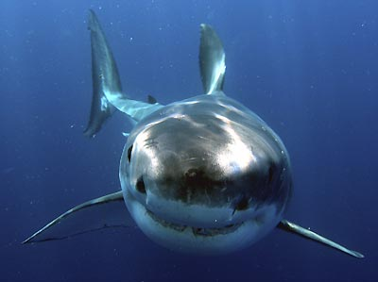
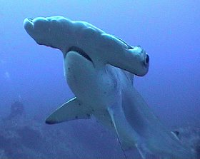
Sharks

Did you know…
- Whale sharks can grow over 14 metres in length.
- Hammerheads grow up to 4 metres long and are found in warm seas.
- The world’s largest fish is the whale shark.
- The longest known great white is 6 metres.

Great white shark.
Hammerhead shark.
Why do hammerhead sharks have a funny shaped head?
There are lots of thoughts about why hammerhead sharks have strange shaped heads. Some think it is to help the shark move through the water. Others think it helps their sense of smell – most hammerheads have nostrils on the outer tips of their heads.

Sharks have rough skin and they cannot fold their fins. Sharks have strong jaws (mouths) and many have sharp teeth, but some have flat grinding teeth. Sharks have a fantastic sense of smell and can sniff out food from huge distances. There are about 350 types of shark; they include some of the largest fish in the world.

Which is the fastest shark?
The short-finned Mako shark is the fastest shark. It is very streamlined and agile (quick). It is thought by some that it can travel up to 70 miles per hour. It eats other fish such as tuna, which are also some of the fastest swimming fish.

How do great whites find their food?
When the great white shark is close to another animal, it can sense electrical currents made by the animal’s body. When they are further away, it has a powerful sense of smell that can track the scent (smell) of fish from a great distance. Great whites have good eye-sight. They see well in the dark and have a good sense of hearing.

Spiders
Spiders are the world’s most common land carnivore (eats meat). There are about 40,000 different types of spiders and they live in nearly every part of the world. All spiders have a pair of fangs; these fangs release venom (poison).

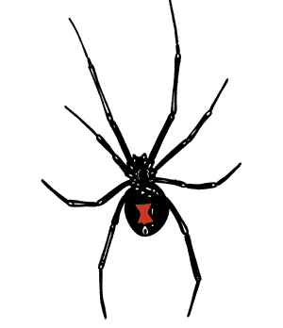
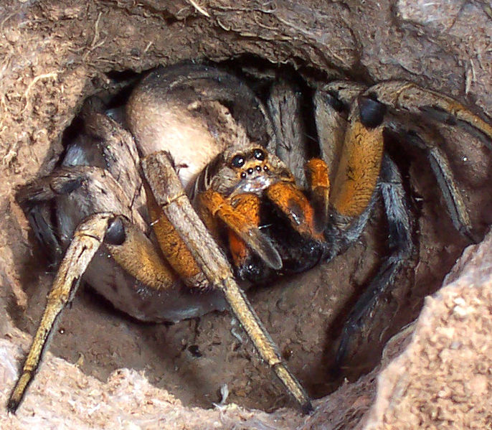
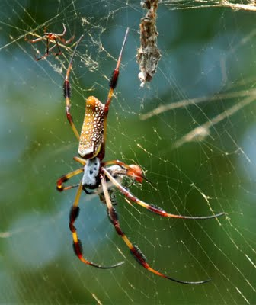
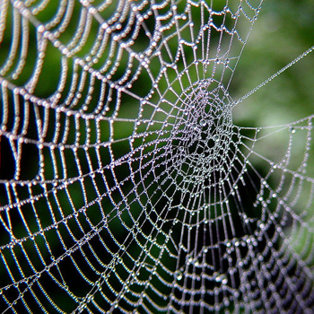
Spider web with rain droplets.

Fun Facts!
- Not all spiders have 8 eyes, some only have 6.
- Tarantulas are the largest spiders.
- Some jumping spiders can jump 30 times their own body length.

Spider waiting to jump on its prey.
Spider on its web.
Black widow spider.
Do all spiders make webs?
Not all spiders make webs, but they all make silk. Many hunt on the ground, like the jumping spiders, and some even build trap-doors under ground so they can hide and wait for their prey (food).

Are black widows dangerous?
There are over 30 types of widow spiders, including the red back in Australia. Both black widow and red back widow are mainly black with a red tummy to warn off predators (any animal that might want to eat them!).

