First News
£1

Local hero helps the homeless


homeless off the streets, little did people know that she meant she wanted to invite them into her own home.

The homeless man, known locally as Mr Stink, is currently living in the shed and is fed by the very kind Crumb family. Mr Stink, speaking about the breakfast service, had this to say, “The

service is very slow.” And, “I love sausages.”

Mrs Crumb is currently campaigning to become local MP, and eventually would like to be Prime Minister. It would be great to see such a kind lady become our MP, and it would be wonderful to see the work she could do for the homeless community. Mrs Crumb said, “It was all my idea, I just love this wonderfully clean gentleman living in my shed. I think that everybody should help the homeless!”

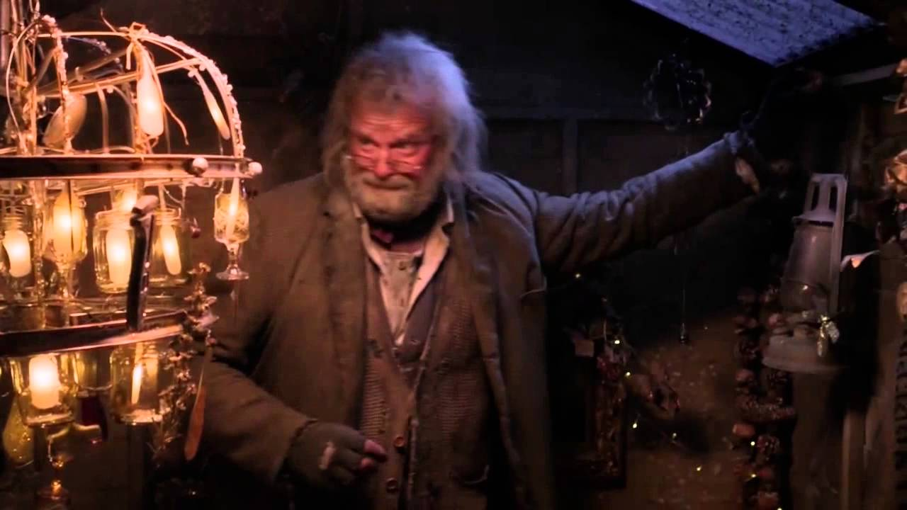

Mr Stink has made the shed very cosy.

By Smith

On the 12th January 2021, it was found that Mrs Crumb, mother of 2 and candidate for MP, is a hero for keeping a homeless man in her shed. Mr Stink, who used to live on the bench, is now living at the Crumb’s residence with his dog Duchess.

Mrs Crumb has put in her policy that she wants the

Mr Stink is happy in his new home.

