First News
£1

Touchdown Confirmed!

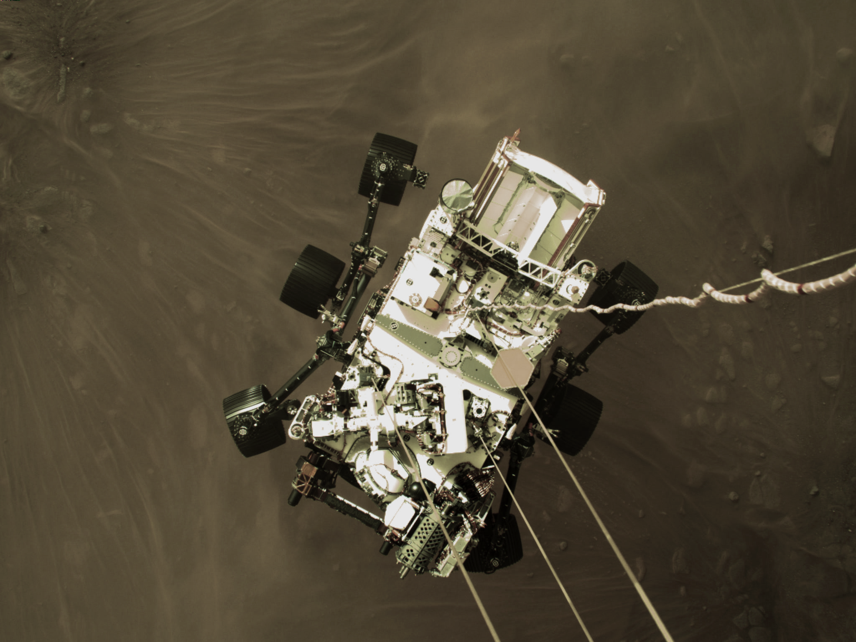
Images taken from the rover have already been sent back to Earth. These include images of the rover’s descent and stunning views of Mars from onboard the lander.

This is a huge achievement for mankind, the people involved in the mission cheered and clapped from the control room when they heard “touchdown confirmed!”

The landing of the Perseverance Rover is just the beginning of this exciting mission. It’s ground-breaking technology will help to collect samples from Mars and to plan for future human exploration of the planet. Steve Jurczyk, Nasa acting administrator had this to say, “It’s part of our bigger exploration plans which involve preparing for eventually human missions to Mars.”

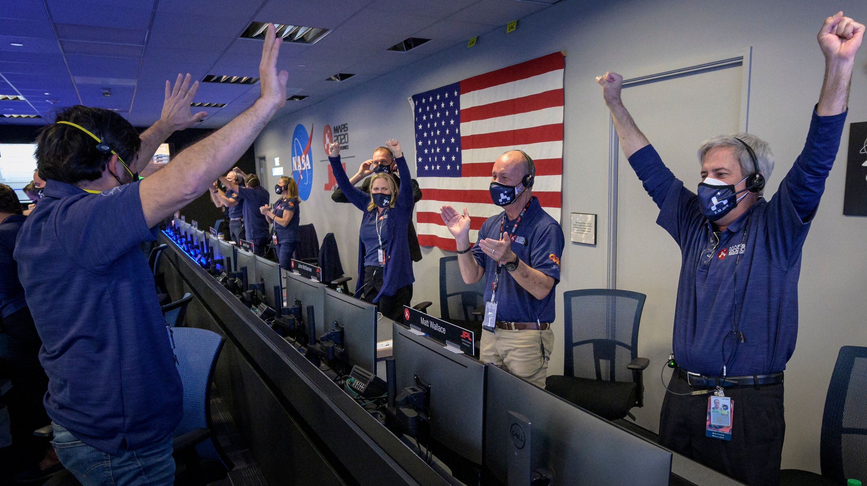

People clapping in the control room at Nasa.

By Smith

On the 18th February 2021, Perseverance Rover safely touched down on Mars. The rover travelled nearly 300 million miles and landed on Jezero Crater.

The landing of Perseverance Rover is part of Mars 2020, which is a mission run by Nasa. The aim of the mission is to see if there is or has been any life on Mars.

Perseverance Rover landing on Mars.

